Que.Creating sample tables and inserting values.create the following tables with the given structures and insert sample data as specified:-

Roll no:-84016

page1
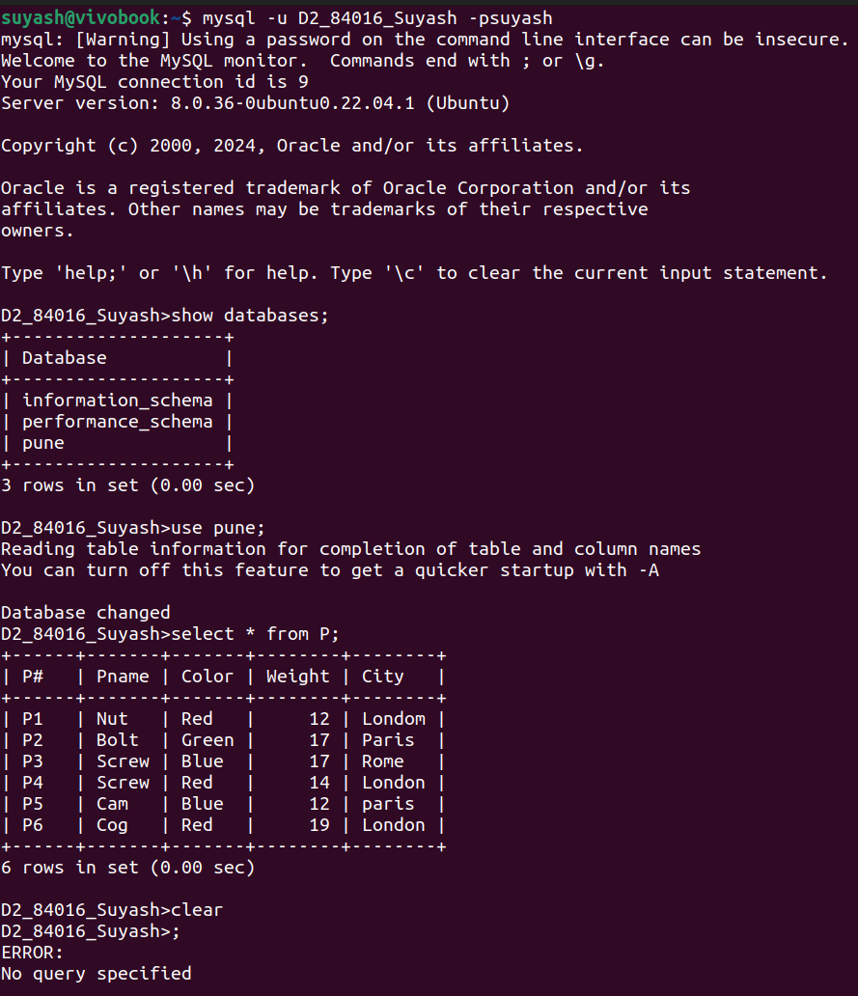
page 2
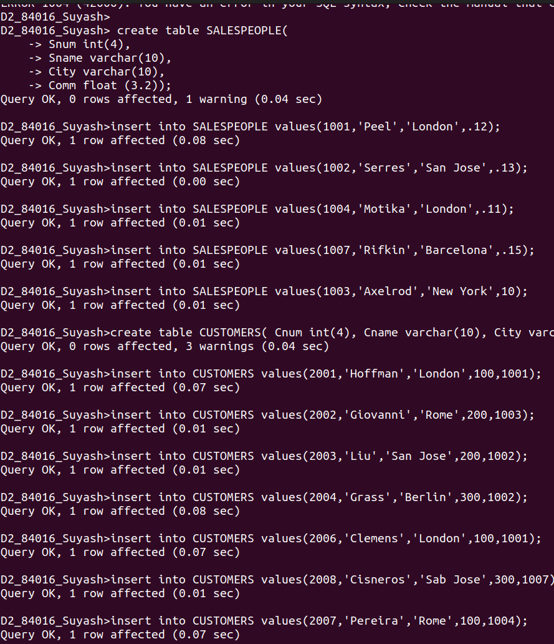
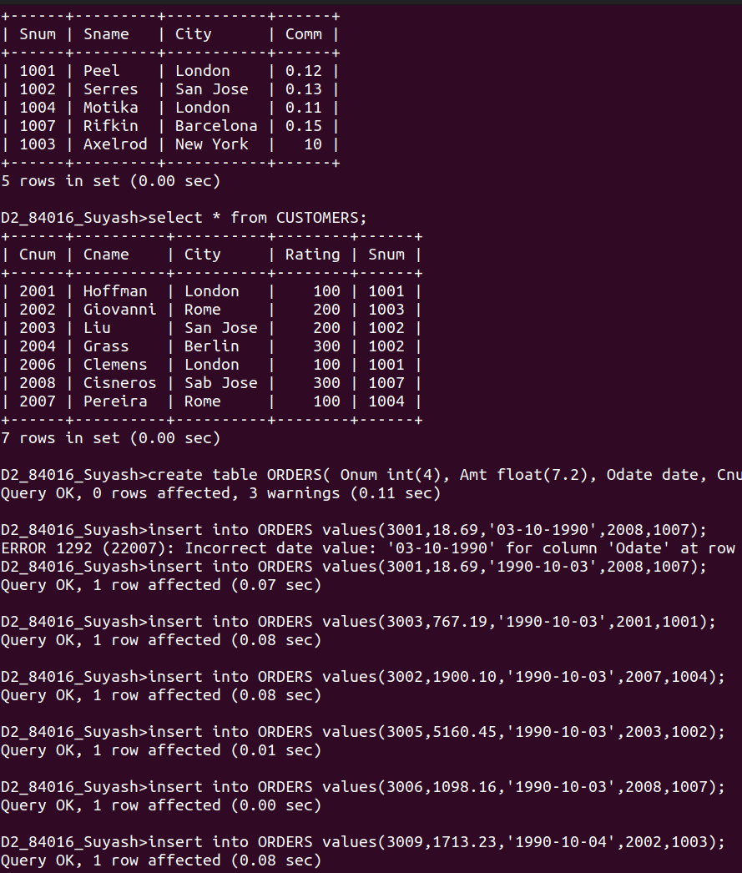
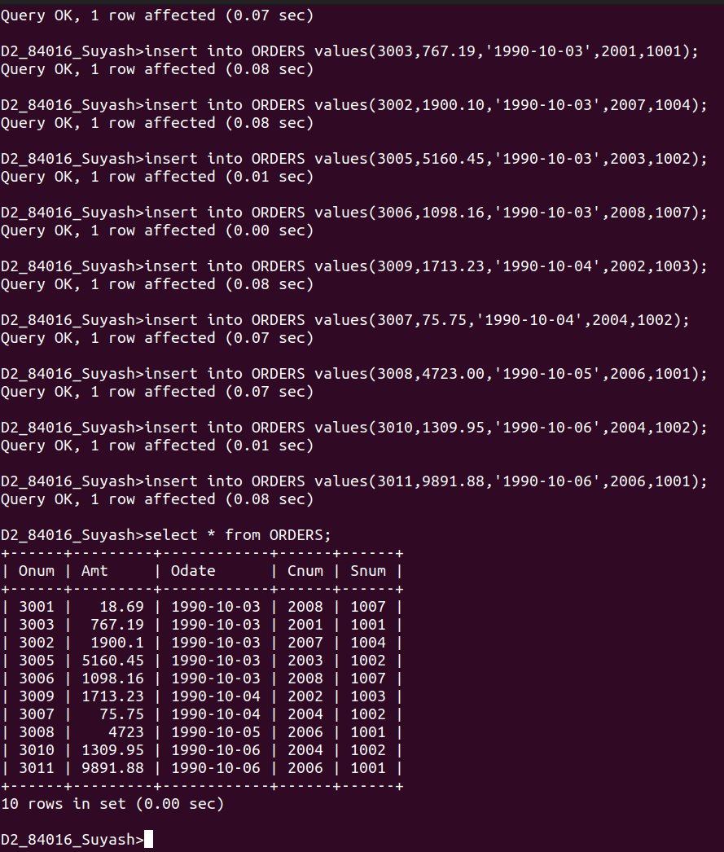
page 3
page 4

